From AI Chatbots to AI Agents

Beyond the “Brain in a Jar”: How Reasoning Engines and ReAct loops are turning text-generators into autonomous workers.
For the last few years, the world has been captivated by Large Language Models (LLMs). We treat them like oracles: we type a question into a box (like ChatGPT), and the oracle speaks back. But:
Why ChatGPT can’t book me a flight to London?
Because there is a limitation. If you ask ChatGPT, “Book me a flight to London for next Tuesday,” it might politely reply, “I can’t do that. I’m just an AI language model.”

The evolution of AI architecture: Moving from Large Language Models as passive text generators to autonomous AI Agents using the ReAct framework by Christian Bernecker
It has the intelligence to understand the request. It knows what a flight is, what London is, and what a Tuesday is. But it lacks the agency to act on that knowledge. It is a “brain in a jar”, disconnected from the world. This is where the next revolution in AI begins.
We are moving from Chatbots to AI Agents.

💡 What we’ll cover:
- ✔️ The Definition: Why a “Librarian” is a better model for AI than an encyclopedia.
- ✔️ The Architecture: A breakdown of the Brain (LLM), the Body (Environment), and the Hands (Tools).
- ✔️ The ReAct Loop: A behind-the-scenes look at the “Internal Monologue” that drives agent autonomy.
- ✔️ The Future: How agents are moving software from autocomplete to autopilot.

The Core Difference between a Chatbot and an Agent: Passive vs. Active
To understand Agents, we simply need to look at the difference between a Tool and a Worker.
Press enter or click to view image in full size
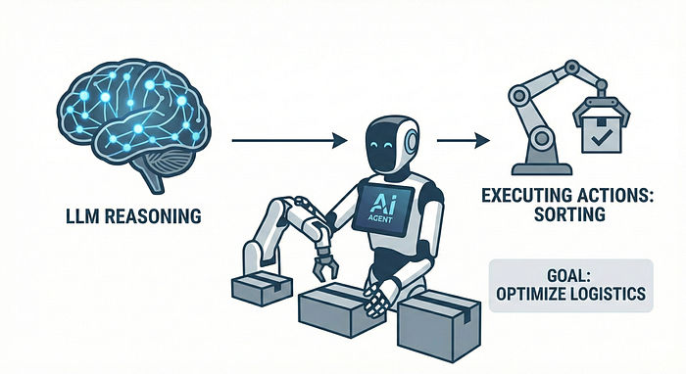
An AI Agent is a system that uses an LLM as its reasoning engine to pursue a goal by executing actions in the real world.
- A Chatbot (The Tool): Imagine a library. The chatbot is a very smart encyclopedia sitting on a shelf. It contains all the answers, but it sits there passively. It only helps you if you walk over, open it, and read it. It cannot leave the shelf.
- An Agent (The Worker): The agent is the Librarian. The Librarian has read the encyclopedia (the LLM), so they are just as smart. But the Librarian also has hands and feet. They can pick up the phone, use the computer, walk to the archives, and send an email.
Agent Definition: An AI Agent is a system that uses an LLM as its reasoning engine to pursue a goal by executing actions in the real world.

The Architecture: Brain, Body, and Tools
To turn a text-generator into an agent, we have to stop treating it like a search engine and start treating it like a manager. This requires three distinct components (Brain, Body, Tools):
Press enter or click to view image in full size
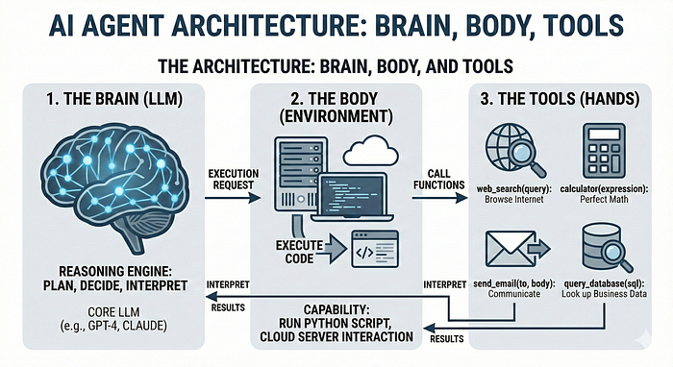
AI Agent Architecture Brain Body Tools Diagram
Now, let’s jump into the details:
1. The Brain (The LLM): This is the reasoning engine (e.g., GPT-4). We no longer ask it to write poems; we ask it to plan. It looks at a goal and decides the logical steps to get there.
2. The Body (The Environment): This is where the work happens. It’s the Python environment or the cloud server that gives the AI a place to “live” and execute commands.
3. The Tools (The Hands): An LLM alone cannot see the live web or move money. We give it pre-defined functions (Skills) like
- web_search(query): Allows it to browse the internet.
- calculator(expression): Allows it to do math perfectly
- send_email(to, body): Allows it to communicate.
- query_database(sql): Allows it to look up business data.
The core shift: The LLM doesn’t solve the problem; it chooses the tool that solves the problem.

The “ReAct” Loop: How Agents Think
If a chatbot is an oracle, an agent is a detective.
When you ask a standard chatbot a complex question, it tries to predict the entire answer in one go. An agent, however, uses a framework called ReAct (Reason + Act). It enters a continuous “Inner Monologue” where it plans, executes, and checks its own work.
The blueprint of autonomy: How an LLM uses tools to bridge the gap between a question and a real-world result.
Notice what happens in the diagram above. The Agent isn’t just “writing”; it is problem-solving. It breaks down a complex request, identifies its own knowledge gaps, uses tools to fill those gaps, and synthesizes the final answer. The user never sees the search queries; they just get the result.
“Who is the CEO of the company that makes the iPhone, and what is his current net worth?”
Press enter or click to view image in full size
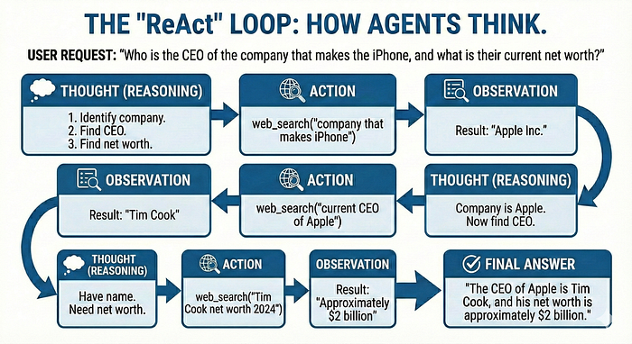
ReAct-Loop AI-Agent Reasoning Flowchart
(Note: I’ll be sharing the full Python implementation of this specific loop in my next post. Follow to stay in the loop.)

The Agent’s Internal Loop:
- Thought (Reasoning): “I need to answer a two-part question. First, I need to identify the company that makes the iPhone. Then I need to find its CEO. Finally, I need to find the CEO’s net worth.”
- Action: web_search("company that makes iPhone")
- Observation: Result: “Apple Inc.”
- Thought: “Okay, the company is Apple. Now I need to find the CEO.”
- Action: web_search("current CEO of Apple")
- Observation: Result: “Tim Cook.”
- Thought: “Now I have the name. I need his net worth.”
- Action: web_search("Tim Cook net worth 2024")
- Observation: Result: “Approximately $2 billion.”
- Final Answer: “The CEO of Apple is Tim Cook, and his net worth is approximately $2 billion.”

Why this matters:
Notice the difference? The user never sees the messy middle. They don’t see the search queries or the filtering of data. They only see the Final Answer.
In this loop, the LLM isn’t just a writer; it is a Reasoning Engine. It uses the Reason phase to decide which tool is needed, and the Observation phase to verify if the tool actually worked. If the search result had been Error 404, the agent’s next Thought would be: “The search failed. I should try searching for ‘Apple executive leadership’ instead.”
This is the definition of Agency: The ability to self-correct until the goal is met.

Why Agents Are the Future
We are currently witnessing a fundamental shift in the DNA of software. We are moving away from software you use and toward software that acts on your behalf.
- From Autocomplete to Autopilot: Coding assistants like Devin don’t just suggest the next line of code; they read your entire codebase, run the tests, observe the error messages, and fix their own bugs.
- From Queries to Insights: Instead of a business owner learning complex SQL, they can ask an agent, “Show me a graph of our sales trends.” The agent writes the code, executes it against the database, and generates the visualization.
- From Apps to Intent: Personal assistants are moving away from screens full of icons. Instead of you navigating five different apps to book a trip, an agent navigates the web for you — ordering the Uber, booking the flight, and sending the calendar invite in one go.

Conclusion: From Information to Action
The transition from Chatbots to Agents is the transition from Information to Action.
A chatbot can tell you how to bake a cake. An agent can order the ingredients, set a kitchen timer, and invite your friends over to eat it.
However, building these systems isn’t magic. It requires clever engineering to prevent the agent from getting stuck in infinite loops or “hallucinating” tool outputs. In my next article, “Under the Hood: Building a ReAct Agent from Scratch,” we will peel back the layers of abstraction and build our very own agent using nothing but Python and an API key.
See you in the code.

Want to Connect?
- Follow me here on Medium to be the first to read Part 2: Under the Hood, where we will write the actual Python code to build a ReAct agent from scratch.
- 👏 Clap for this article (you can go up to 50!) if you found the “Librarian vs. Encyclopedia” metaphor helpful — it helps other builders find this guide.
- 🤝 Connect with me on LinkedIn for weekly insights on AI architecture and the shift toward autonomous agents.
What’s one task you wish an AI Agent could do for you today? Let’s discuss in the comments!

Artificial Intelligence

AI Agent

LLM

Machine Learning

Future Of Work

141



Published in Level Up Coding

304K followers
·Last published 1 day ago
Coding tutorials and news. The developer homepage gitconnected.com && skilled.dev && levelup.dev
Follow



Written by Christian Bernecker

380 followers
·74 following
AI enthusiast, speaker, and software developer passionate about leveraging technology to improve the world. Always happy to share knowledge and connect.
Follow

No responses yet

Spiraltrain
﻿
Cancel
Respond

More from Christian Bernecker and Level Up Coding

Christian Bernecker

Feature Engineering for Machine Learning: A Practical Guide with Scikit-learn

In machine learning, your data is the fuel, and feature engineering is the process of refining it into high-octane energy for your models

Sep 24, 2025

22

In

Level Up Coding

by

Teja Kusireddy

Google Is Quietly Dismantling Everything OpenAI Built

The most dangerous failure in Silicon Valley isn’t bankruptcy. It’s becoming the engine inside someone else’s car.

Feb 17

3.8K
128

In

Level Up Coding

by

Teja Kusireddy

I Stopped Using ChatGPT for 30 Days. What Happened to My Brain Was Terrifying.

91% of you will abandon 2026 resolutions by January 10th. Here’s how to be in the 9% who actually win.

Dec 28, 2025

8.5K
322

Christian Bernecker

Principal Component Analysis (PCA) for Dimensionality Reduction with Python and Scikit-learn

While more data can be good, too many features (or dimensions) can lead to a problem known as the “Curse of Dimensionality.”

Sep 26, 2025

33

See all from Christian Bernecker

See all from Level Up Coding

Recommended from Medium

In

Level Up Coding

by

Teja Kusireddy

Google Is Quietly Dismantling Everything OpenAI Built

The most dangerous failure in Silicon Valley isn’t bankruptcy. It’s becoming the engine inside someone else’s car.

Feb 17

3.8K
128

In

CodeX

by

MayhemCode

Why Thousands Are Buying Mac Minis to Escape Issues with Big Tech AI Subscriptions Forever |…

Something strange happened in early 2026. Apple stores started running low on Mac Minis. Tech forums exploded with setup guides. Developers…

Feb 15

3.2K
53

In

Towards Deep Learning

by

Sumit Pandey

Andrej Karpathy Just Built an Entire GPT in 243 Lines of Python

No PyTorch. No TensorFlow. Just pure Python and basic math.

Feb 15

2.6K
36



In

AI Advances

by

Jose Crespo, PhD

Anthropic is Killing Bitcoin

The AI-native currency already exists — hiding in plain sight, outperforming crypto by six orders of magnitude.

Feb 17

2.7K
120

In

Activated Thinker

by

Shane Collins

Why the Smartest People in Tech Are Quietly Panicking Right Now

The water is rising fast, and your free version of ChatGPT is hiding the terrifying, exhilarating truth

Feb 13

11K
480

In

Towards AI

by

Florian June

Cog-RAG: Giving RAG a Brain That Thinks Before It Retrieves

Retrieval-Augmented Generation (RAG) is now a standard way to help LLMs stay grounded. The basic idea is familiar: slice documents into…

Feb 17

203
1

See more recommendations

Help

Status

About

Careers

Press

Blog

Privacy

Rules

Terms

Text to speech

